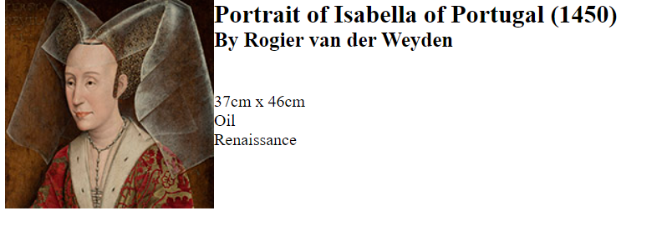

Set variables in art_data.php file, called file using : include and set echo within the lab12a-test01.php to display the content

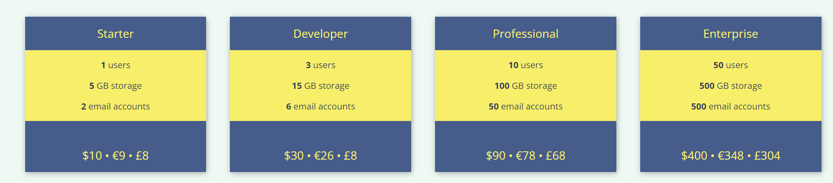

Connected functions from one PHP file to another and called the functions within the html code to show the tables you see above